Python Installation

Getting Started with Python
Python is a general purpose, high level programming language that is used in a variety of application domains. The Python language has a very clear and expressive syntax as well as a large and comprehensive library. Although Python is often used as a scripting language, it can also be used in a wide range of non-scripting contexts. It’s available for all major Operating Systems: Windows, Linux/Unix, OS/2, Mac, Amiga, among others. Python is free to use, even for commercial products, because of its OSI-approved open source license.

Python 2 or Python 3?
Python has two standard versions, Python 2 and Python 3. The current production versions (July 2012) are Python 2.7.3 and Python 3.2.3. Python 2.7 is the status quo. We recommend you use Python 2.7 for completing the assignments.

Installing Python
Python can be downloaded directly from the official website http://www.python.org/ . This is the program that is used to write all your python code. On the left side of the website there is a download section

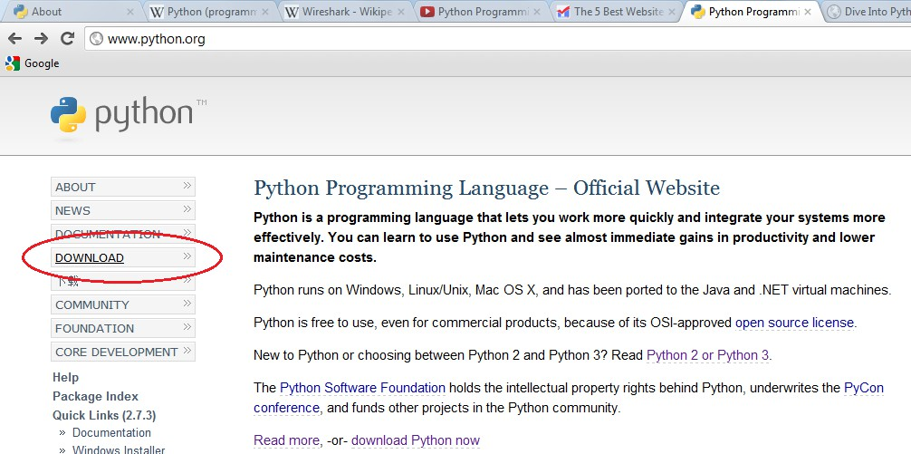

Clicking the download link will present you with two versions of Python, namely python 2 and python 3; you can also choose the version specific to your operating system. Most popular Linux distributions come with Python in the default installation. Mac OS X 10.2 and later includes a command-line version of Python, although you'll probably want to install a version that includes a more Mac-like graphical interface.

Installing Python on Window

- Double-click the installer, Python-2.xxx.yyy.exe. The name will depend on the version of Python available when you read this.
- Select run.
- Step through the installer program.
- If disk space is tight, you can deselect the HTML Help file, the utility scripts (Tools/), and/or the test suite (Lib/test/).
- If you do not have administrative rights on your machine, you can select Advanced Options, then choose Non-Admin Install. This just affects where Registry entries and Start menu shortcuts are created.
- If you see the following that means the installation is complete.

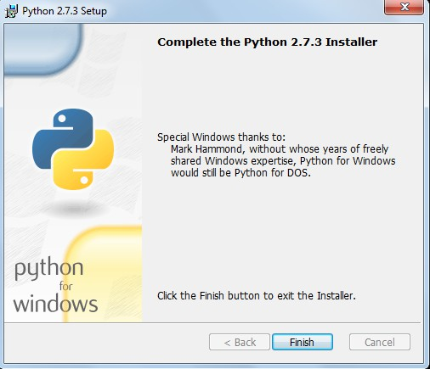

- After the installation is complete, close the installer and select Start->Programs->Python 2.3-
>IDLE (Python GUI). You'll see something like the following:

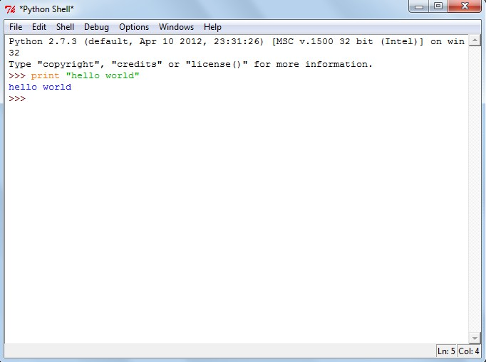

Other Window Installation Options
ActiveState makes a Windows installer for Python called ActivePython, which includes a complete version of Python, an IDE with a Python-aware code editor, plus some Windows extensions for Python that allow complete access to Windows-specific services, APIs, and the Windows Registry. ActivePython is freely downloadable, although it is not open source. You recommend you use this for writing more complicated programs.

Download ActivePython from http://www.activestate.com/Products/ActivePython/.If you are using Windows 95, Windows 98, or Windows ME, you will also need to download and install Windows Installer 2.0 before installing ActivePython.

Installing Python On Mac
The latest version of Mac OS X, Lion, comes with a command line version preinstalled. This version is great for learning but is not good for development. The preinstalled version may be slightly out of date, it does not come with an XML parser, also Apple has made significant changes that can cause hidden bugs.
Rather than using the preinstalled version, you’ll probably want to install the latest version, which also comes with a graphical interactive shell.

Running the Preinstalled Mac Version
Follow these steps in order to use the preinstalled version.

- Go to Finder->Applications->Utilities.
- Double click Terminal to get a command line.

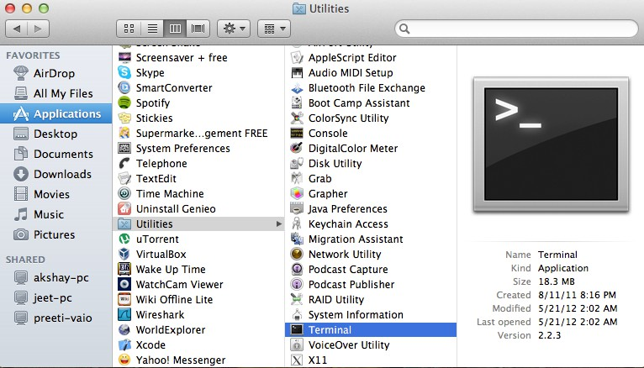

- Type python at the command prompt

- Now you can try out some basic codes here

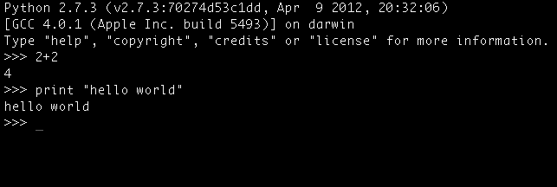

Installing the Latest Version on the Mac
As said earlier Python comes preinstalled on Mac OS X , but due to Apple’s release cycle, its often a year or two old. The “MacPython” community highly recommends you to upgrade your Python by downloading and installing a newer version.
Go to http://www.python.org/download/ and download the version suitable for your system from among a list of options.
The downloaded file should look like this

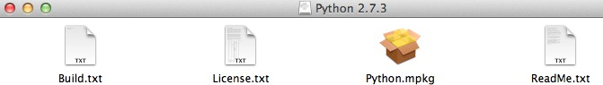

Double click the “Python.mpkg” file. The installer may prompt you for your administrative username and password.

Step through the installer program.
You can choose the location at which it is to be installed.

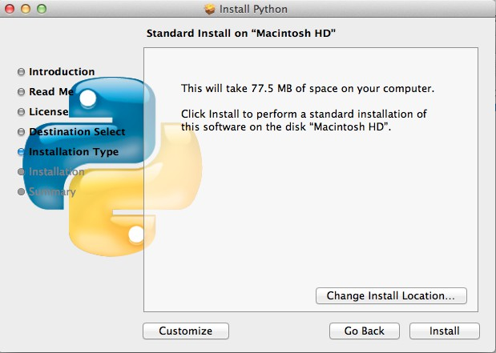

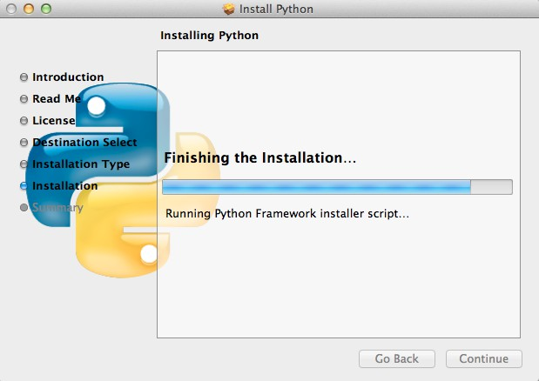

After the installation is complete, close the installer and open the Applications folder , search for Python and you’ll see the Python IDLE i.e. the standard GUI that comes with the package.

Alternative Packages for Mac OS X
ActiveState ActivePython: (commercial and community versions, including scientific computing modules). Active Python also includes a variety of modules that build on the solid core.

Enthought Python Distribution: The Enthought Python Distribution provides scientists with a comprehensive set of tools to perform rigorous data analysis and visualization.

Example of a Basic Python Program
The interface “Idle” that we opened so far is only useful for testing out basic python commands or can otherwise be used as a calculator, it basically means the program cannot be saved this way.
To save a program and execute it we need to follow the following instruction: On the top left corner of “Idle” select File -> New Window.
The new window that pops out will allow you to save and execute your python programs. You can write your python code in this window. Try the following:

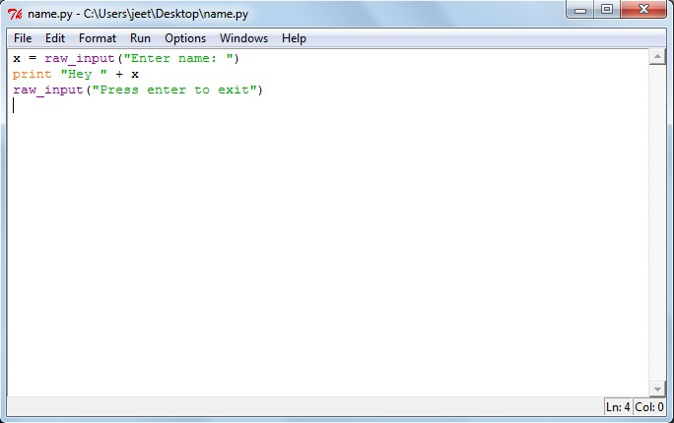

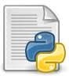
We cannot run this program without saving it. A saved python file has an icon that looks like this

You run the program by pressing F5 or Run-> Run Module. You can also run the program by simply double clicking the file icon. When you open a saved file to run the program, you should see:

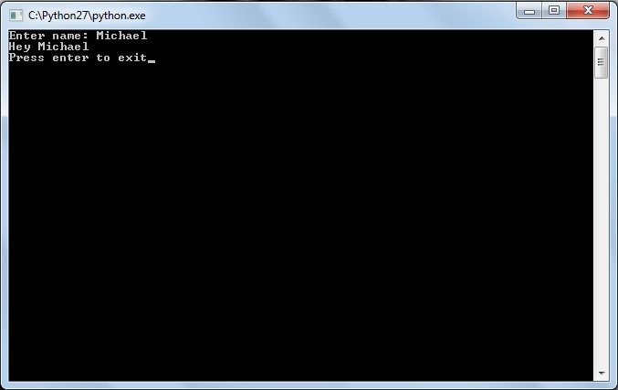

Learning Python Programming
Python is easy to learn, easy to use and very powerful. There are a lot of web resources for learning the language, most of which are entirely free. We recommend Sthurlow.com's A Beginner's Python Tutorial
http://www.sthurlow.com/python/

